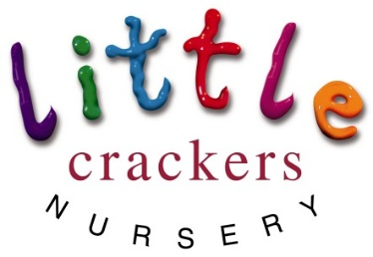
Weekly News

26th January 2017

Next week:  Our big story will be:  ‘Mr Gumpy’s Outing’  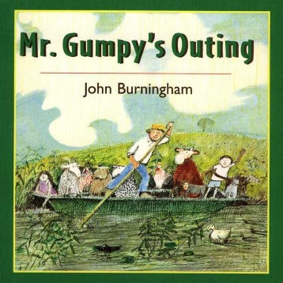  Rugby Tots  Wednesday afternoon  2’s 3’s and 4’s are welcome…  Please ask for details if you are interested.  Winter blues… infection control!  If you have calpol…  stay away from nursery for 24hrs  If you have antibiotics…  stay away from nursery for 48hrs  This weekend you could:  Tell the story of The Three Little Pigs to someone in your family – without a book!  Make a collection of 3 things, bring in a photo  Draw a picture of the pigs and their houses  Build a house out of straw!!!! | a b c d e f g h i j k l m n o p q r s t u v w x y z  Focus on Sounds:  As we start to introduce letter shapes into our writing area many children are beginning to identify the letters in their names. Whilst we are not formally teaching the letter sounds yet, (this is a job for Reception), we are very keen to encourage our children to be interested in the letters they see and the sounds they hear. One of the most important things we need to learn at this point, is the correct way to pronounce those sounds. For example:  m is mmm not muh or em  s is sss not suh or es  we also use the following language with the children, they might tell you about:  stretchy sounds are long e.g. f is “fffff”  bouncy sounds are short e.g. a is “a. a. a.”  it is also worth knowing:  the letter name is the sound you recognise from the ‘alphabet song’, e.g. ‘ay bee see’. This is not important to know until much later in Reception and we don’t ever say or use these in Nursery.  a b c d e f g h i j k l m n o p q r s t u v w x y z  Joke of the week:  Why couldn’t the pirates play cards?  The Captain was standing on the deck!!!!
Little Crackers Nursery · Crackley Hall · St Joseph’s Park · Kenilworth · CV8 2FT
Telephone: 01926 514444 · Fax: 01926 514455 · e-mail: littlecrackers@crackleyhall.co.uk
www.crackleyhall.co.uk

Registered Charity Number 1087124 Company limited by guarantee Number 4177718

You can email Mrs Bird clarebird@crackleyhall.co.uk
or ring the nursery direct 01926 514456

